

**Project Document**

**Name :NAVEENKUMAR J**

**Register Number :720722110019**

**Department :IT-A**

**Year :2024**

**Project Title**

**DESIGN THINKING IN HEALTH CARE SERVICE**

**Template Name**

**RETROSPECTIVE**

**Problem Statement**

**Problem Statement:**

**"In retrospect, the implementation of electronic health records (EHRs) within our healthcare system has revealed significant challenges, including usability issues, provider burnout, and limitations in interoperability. Despite initial expectations of improved efficiency and coordination of care, the retrospective analysis highlights a need to address these barriers to fully realize the potential benefits of EHRs in enhancing patient outcomes and healthcare delivery."**

**Project description**

**"Our retrospective project aims to conduct a comprehensive analysis of the implementation and impact of electronic health records (EHRs) within our healthcare system. Through this project, we will examine various aspects of EHR usage, including usability, provider satisfaction, patient outcomes, and healthcare delivery processes. The project will involve collecting and analyzing data from EHR systems, conducting surveys and interviews with healthcare providers and administrators, and reviewing relevant literature and best practices.**

**Key components of the project include:**

**1. Evaluation of Usability: Assessing the usability of EHR systems by identifying common challenges and areas for improvement in user interface design, workflow integration, and data entry processes.**

**2. Provider Satisfaction: Investigating provider satisfaction with EHRs through surveys and interviews to understand their experiences, perceptions, and suggestions for enhancing EHR usage.**

**3. Impact on Patient Outcomes: Analyzing the impact of EHR usage on patient outcomes, including clinical outcomes, safety measures, and patient satisfaction scores.**

**4. Workflow Analysis: Examining the impact of EHRs on healthcare delivery processes, including documentation practices, communication between providers, and coordination of care.**

**5. Identification of Best Practices: Identifying best practices and lessons learned from successful EHR implementations within our healthcare system and from external sources.**

**6. Recommendations for Improvement: Developing recommendations and action plans based on the findings of the retrospective analysis to address identified challenges and optimize the use of EHRs to improve patient care and healthcare delivery.**

**The project will involve collaboration between healthcare providers, administrators, IT professionals, and researchers to ensure a comprehensive and data-driven approach to understanding the strengths and weaknesses of our current EHR system. By conducting this retrospective analysis, we aim to identify opportunities for improvement and implement strategies to enhance the usability, effectiveness, and impact of EHRs within our healthcare system."**

**Worked Template with explanation**

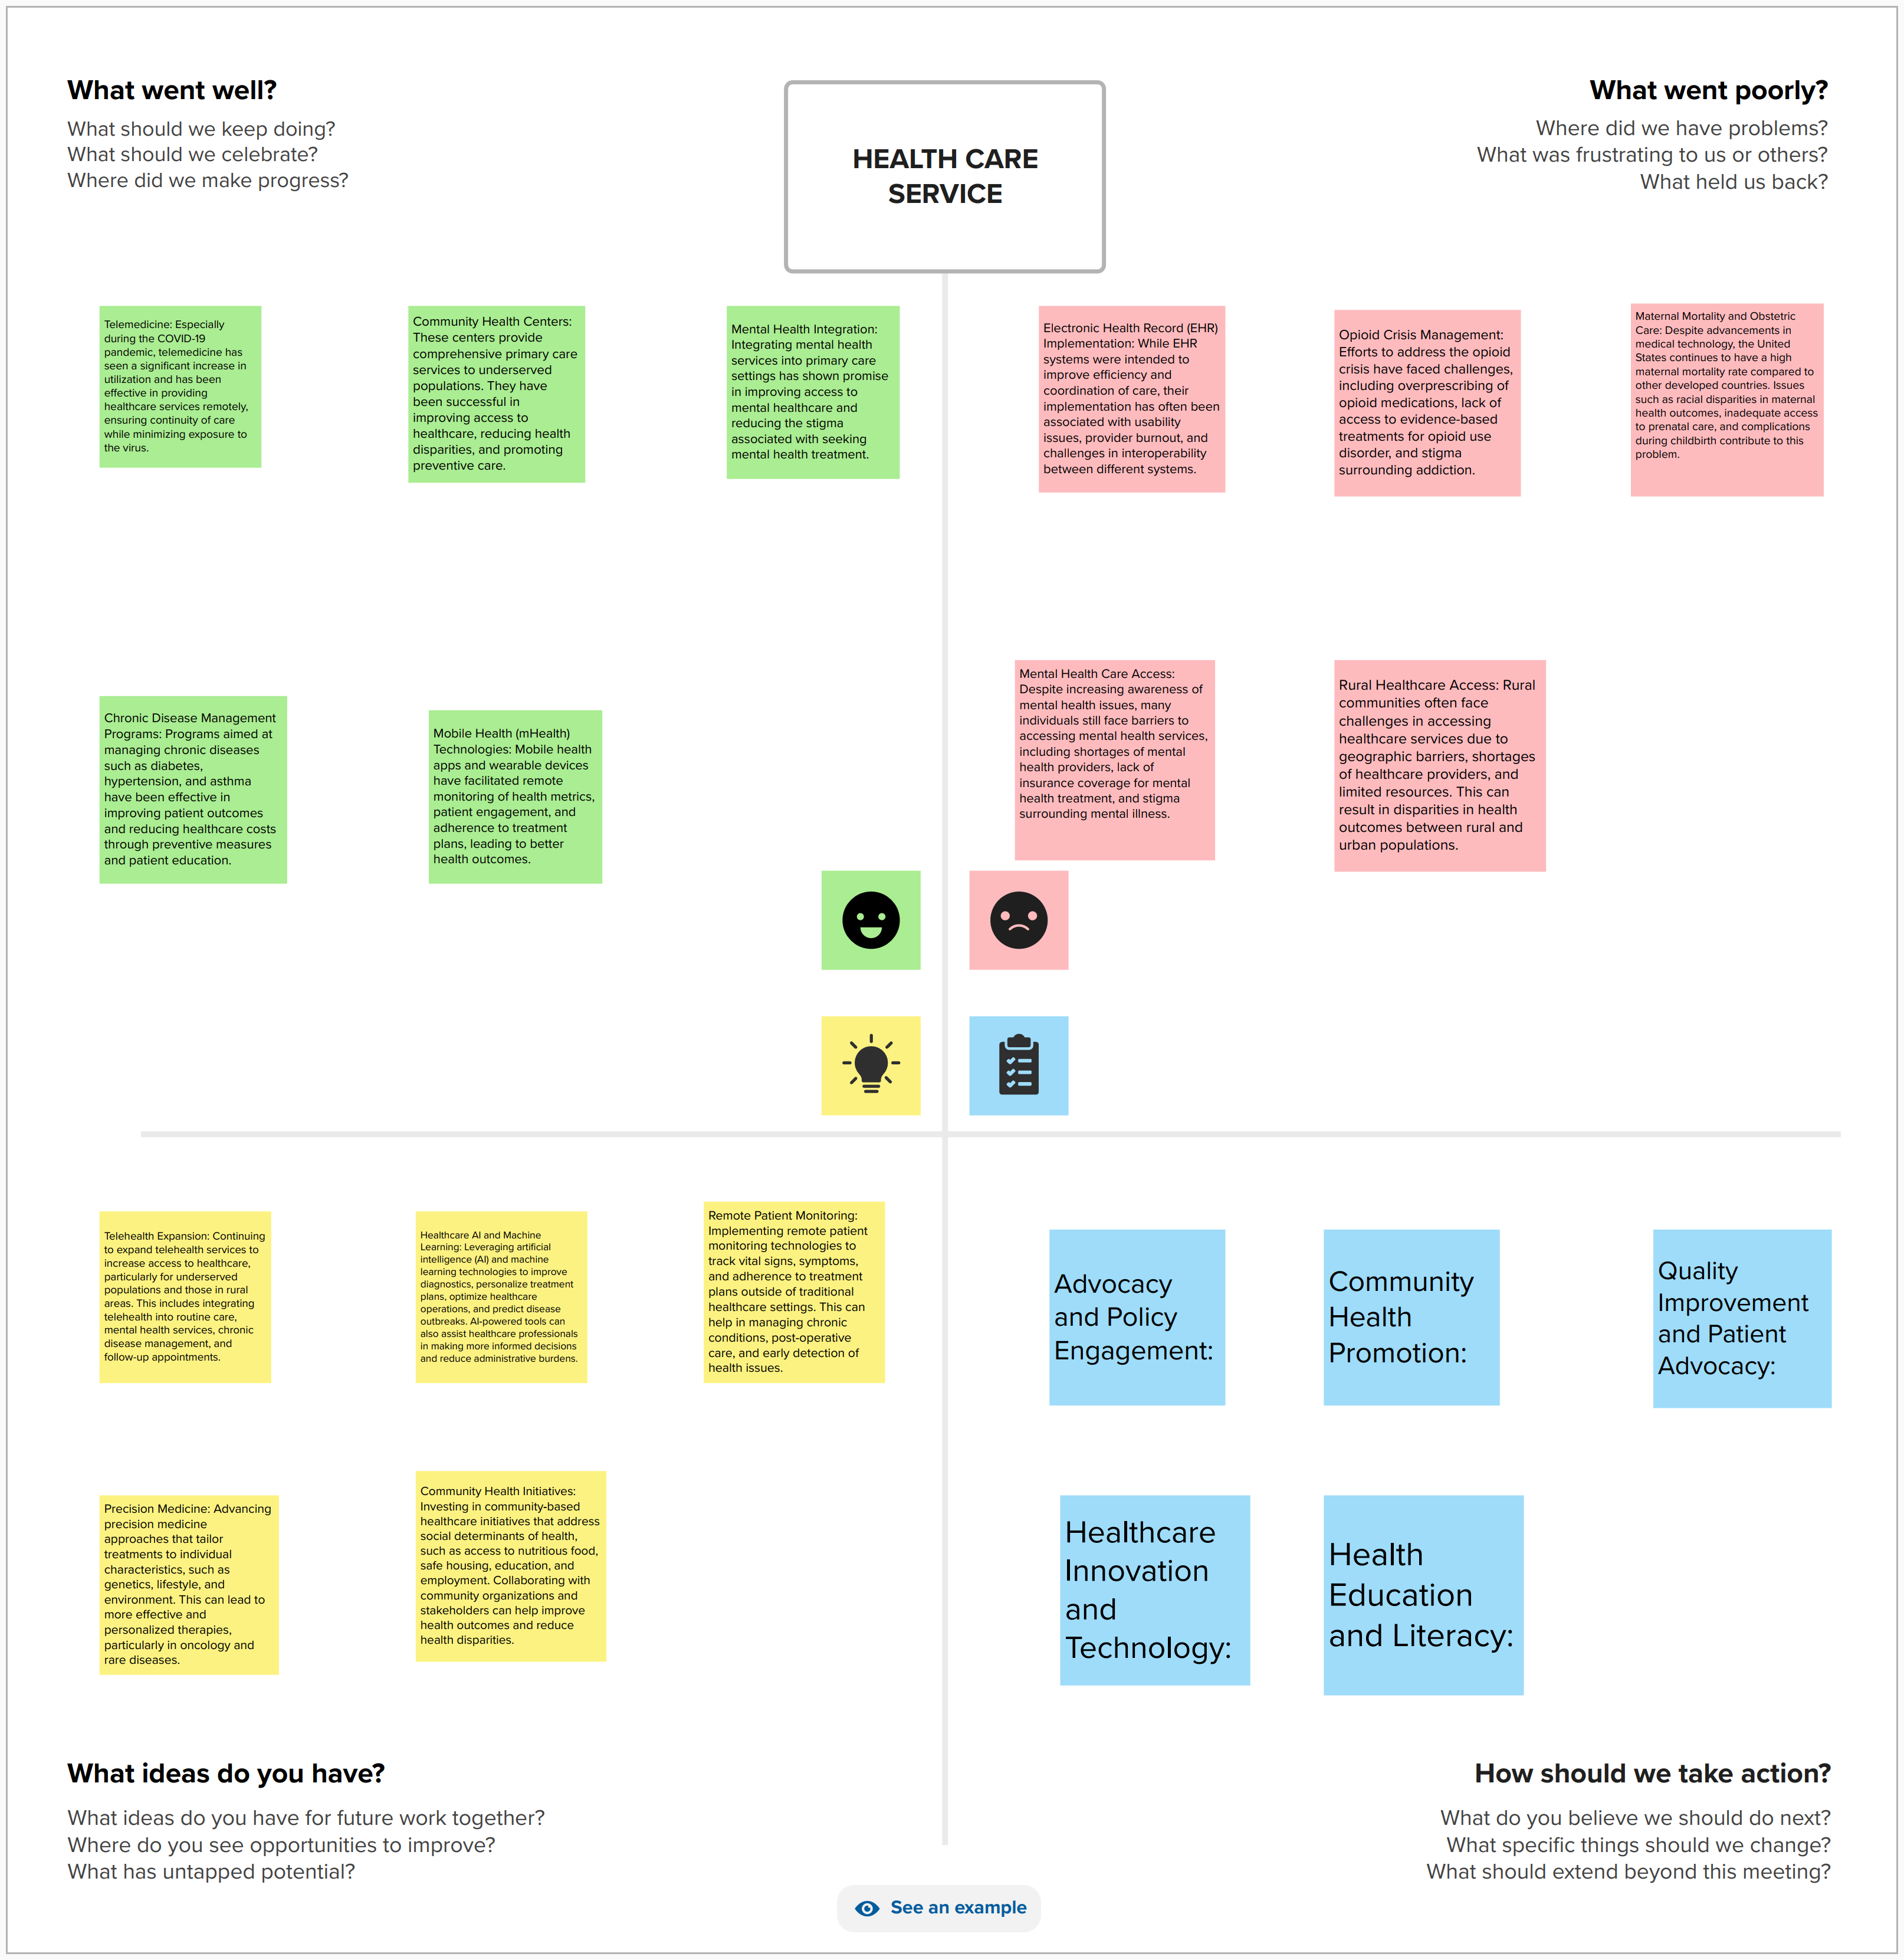

**A retrospective project in healthcare involves conducting a systematic review and analysis of past events, processes, or interventions within the healthcare system to assess their effectiveness, identify areas for improvement, and inform future decision-making. This project aims to provide a comprehensive understanding of the factors that contributed to the outcomes of the past initiatives or practices, with the ultimate goal of driving positive change and optimizing healthcare delivery.**

**Key components of a retrospective project in healthcare include:**

**1. **Scope Definition**: Clearly defining the scope and objectives of the retrospective project, including the specific aspect of healthcare delivery or intervention being examined, the timeframe of analysis, and the desired outcomes.**

**2. **Data Collection**: Gathering relevant data, documentation, and information related to the past events or interventions under review. This may include patient records, clinical data, quality improvement metrics, stakeholder feedback, and other relevant sources of information.**

**3. **Analysis and Evaluation**: Analyzing the collected data to evaluate the effectiveness, impact, and outcomes of the past events or interventions. This involves identifying key performance indicators, trends, patterns, and areas of success or concern.**

**4. **Identification of Lessons Learned**: Identifying lessons learned from the retrospective analysis, including what worked well, what didn't, and why. This may involve recognizing successful strategies, best practices, and areas for improvement or optimization.**

**5. **Recommendations for Improvement**: Developing actionable recommendations based on the findings of the retrospective analysis to address identified challenges, capitalize on strengths, and enhance future healthcare practices or interventions.**

**6. **Communication and Dissemination**: Communicating the findings and recommendations of the retrospective project to relevant stakeholders within the healthcare organization or community. This may involve presenting findings in reports, presentations, or meetings, and engaging stakeholders in discussions about implications and next steps.**

**7. **Implementation of Recommendations**: Supporting the implementation of recommendations derived from the retrospective analysis by collaborating with stakeholders, allocating resources, and monitoring progress towards desired outcomes.**

**8. **Continuous Improvement**: Establishing mechanisms for ongoing monitoring, evaluation, and adaptation to ensure that lessons learned from the retrospective project are integrated into future decision-making processes and contribute to continuous improvement in healthcare delivery.**

**Overall, a retrospective project in healthcare serves as a valuable tool for reflection, learning, and improvement. By systematically reviewing past experiences and outcomes, healthcare organizations can enhance their capacity to deliver high-quality, patient-centered care and achieve better health outcomes for individuals and communities.**

**GitHub Link:**